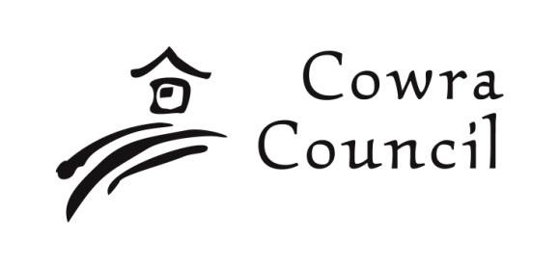
Cowra Shire Council Private Bag 342

Cowra NSW 2794
Phone: 02 6340 2000 council@cowra.nsw.gov.au www.cowracouncil.com.au

Access Incentive Scheme Grant: Acquittal Form

Please submit your completed form to:
Cowra Shire Council, Environmental Services, 116 Kendal Street, Cowra NSW 2794 or, email to: council@cowra.nsw.gov.au

Applicant Details
Contact Name
Name of Organisation
Mailing Address
Contact number during office hours
Email

Project Details
Project Name
Funding Amount Approved | $
Property/Business Name of project site
Property address of project
Location on site where project was completed (e.g. front door)

Project Results
Aim of the Project
(i.e. what will be the outcome? What do you hope to achieve? Who/what will benefit?)
Example: Enable access for wheelchairs to front entrance.
Project Activities.
(Brief Description of what you did, where and when, who was involved, were there any variations to the original application)
Example: New ramp installed to front of building to facilitate equitable access to the building. Ramp was installed on 3 July 2022 by Joe Smith Contractors. Additional handrail was required to be installed to afford stable access to premises
This may be conveyed using dot points.
Project Outcomes
(Brief description of what you achieved, what the benefits were/are to the community / public)
Please include photos

Budget and Expenditure
Brief outcome of grant expenditure: attach copies of receipts and invoices, materials, services, etc.

This page is for record keeping only (with all personal bank details redacted) and will be removed before the form appears in any Council agendas and/or Councils website and/or any social media platform.
Photos
Please attach good quality photos of your project during progress (if any) and of the completed project.
DISCLOSURE: photos may be used on Councils social media, Councils website and in the local newspapers/social media.
Please tick one of the below options.
I consent to all images provided being used on;
(please tick all options below that you give consent to)
Councils website
Social media where the images may be shared by the public Featuring in the local newspaper.
I do not consent to images provided being used on Councils website, on Social media or in the local media publications.
Payment Options
Preferred Payment Method and Details
Cheque Payee: _____________________________________
EFT
Account Name: ____________________________________
BSB Number: ________________
Account Number: _______________________

Important Notes
- Please note, your form may appear in an Access Committee and/or Council meeting agenda where it will then be available online. It may also appear on Council’s Facebook page where the post may potentially be shared by the public. All personal information will be redacted before appearing online.
- Please ensure you have ticked whether you give consent or not for the use of any photos provided to appear in a public article and/or online post where it may be shared.
Contact the Director-Environmental Services or the Director-Environmental Services Personal Assistant at Cowra Council for any assistance in completing your form on 6340 2048 or by email at: council@cowra.nsw.gov.au

