Cowra Shire Council
Private Bag 342
Cowra NSW 2794

Phone: 02 6340 2040
council@cowra.nsw.gov.au
www.cowracouncil.com.au

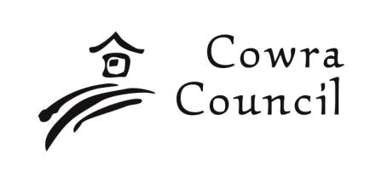
Owners Authorisation for Council Applications

1a. Owners Authorisation - not on behalf of a company, business or body corporate
I, as the owner of the land, give my authority for this application to be lodged. I understand that it will be necessary for Council staff to inspect the property, the subject of this application to ensure compliance with the provisions of the Local Government Act and the Environmental Planning & Assessment Act and the regulations thereunder, and with the approved plans & specifications. Therefore, I give approval for Council staff to inspection the property during the approval process; during construction and until such time as all of the work has been completed to Council’s satisfaction.
Owner(s) Name

Owner(s) Address

Owner(s) Signature

Date:
/ /

OR
Properties held in company, business or body corporate names must complete one of the following:
Executing a document without a company seal
A company may execute a document without using a common seal if the document is signed by:
- 2 directors of the company; or
- A director and a company secretary of the company; or
- For proprietary company that has a sole director – that director, if:
  - The director is also the sole company secretary; or
  - The company does not have a company secretary.

1a. Company Authorisation - SOLE DIRECTOR only
Signed in accordance with Section 127 of the Corporations Act 2001 (Cth) by the:
Company Name:

Sole Director/Secretary Name:

Sole Director/Secretary Address

Sole Director/Secretary Signature

Date:
/ /
OR
1b. Company Authorisation – signed by 2 DIRECTORS or 1 DIRECTOR and 1 SECRETARY
Signed in accordance with Section 127 of the Corporations Act 2001 (Cth) by:
Company Name:

Director Name:

Director Address

Director Signature

Date:
/ /
Director/Secretary Name:

Director/Secretary Address

Director/Secretary Signature

Date:
/ /

2. Subject Land
Street/Rural Address No. | Street/Road Name
Suburb or Town

Lot No. | Section No. | DP No.
3. Description of Proposed Development or Use

NOTE:
This form must be signed by every person who has an interest in the land as owner or part owner.

