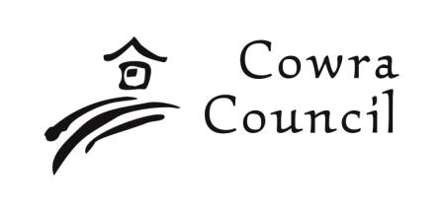 | Cowra Shire Council  Private Bag 342  Cowra NSW 2794  Phone: 02 6340 2040  Fax: 02 6340 2011  council@cowra.nsw.gov.au  www.cowracouncil.com.au
Pre Development Application Enquiry Form

Please Note:

- One set of plans of the development must be submitted with this form and a written statement detailing the proposal in full. If insufficient information is provided Council will be unable to undertake a preliminary assessment of your proposal and this form will be returned to you.
- The personal information required on this form may be available for public access under various legislation.
- Council staff will contact you within 7 days of receipt of this Pre-Development Application enquiry to arrange a mutually convenient meeting time or alternatively we will provide you with written comments on the development proposal within 14 days of pre-lodgement.

- Proponent Details

Name  Mr Miss Ms Mrs |  | Other:
Name

Postal Address

Suburb or Town | State |  |  | Postcode
Telephone | Fax |  |  | Mobile
E-mail

Proponent(s) signature(s) |  |  | Date

2. Property Details

Street No./Rural Address No. | Street/Road Name
Suburb or Town

Lot No(s). | Section No(s). | DP No(s).

3. Details of Proposal

Description of Proposed Development:
Continued overleaf

