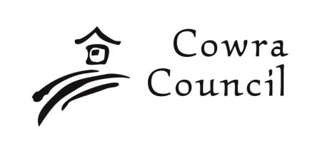 | Cowra Shire Council  Private Bag 342  Cowra NSW 2794  Phone: 02 6340 2040  Fax: 02 6340 2011  council@cowra.nsw.gov.au  www.cowraregion.com.au

Rural Addressing

Please tick as applicable:
[ ] Request for NEW rural address number/s and number plate/s
[ ] Request for REPLACEMENT rural address number plate/s

APPLICANT
Name:
Postal address:
Phone: |  | Mobile:

PROPERTY
Lot: |  | Section: |  | DP:
Lot: |  | Section: |  | DP:
Lot: |  | Section: |  | DP:
Lot: |  | Section: |  | DP:
Existing property name or number:
Road name:
Locality:
Nearest cross road:
Related Development/Subdivision Application no. (if applicable):
New addressing
If more than one entrance requires a number, please specify how many:

Replacement plate/s
If replacement/s required, please specify number/s:

LW:18/8/2010 Please turn over to Page 2 /…..

SITE MAP

Please indicate the position of the gate/s to be numbered in relation to your block.

If more than one gate is to be numbered, please indicate which gate is the main entrance.

_ _ _ _ __ _ _ _ __ _ _ _ __ _ _ _ __ _ _ _ __ _ _ _ __ _ _ _ __ _ _ _ __ _ _ _ __ _ _ _ __ _ _ _

OFFICE USE

Amount Paid: $ _____________ Receipt No: _________________ Date: ____________

Road measured from ________________________________ ODD / EVEN No Required

Distance measured ________________ m, /10 _____________ , rounded _____________

{ } Authority updated { } RA Register updated { } Number plate issued { } Aust Post advised

LW:18/8/2010

Page 2 of 2

