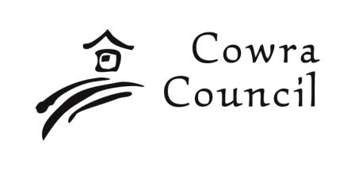 | Cowra Shire Council  Private Bag 342  Cowra NSW 2794  Phone: 02 6340 2040  Fax: 02 6340 2011  council@cowra.nsw.gov.au  www.cowracouncil.com.au
Section 82A Review Application

- Applicant Details

Name  Mr Miss Ms Mrs |  | Other:
Name

Postal Address

Suburb or Town | State |  | Postcode
Telephone | Fax |  | Mobile
E-mail

Applicant(s) signature

2. Site Details

Street/Rural Address No. | Street/Road Name
Suburb or Town

Lot No. | Section No. | DP No.

3. Owners Consent

I/we consent to this application
Owner(s) Name

Owner(s) Address

Owner(s) Signature

Date:
/ /

4. Development Consent Details

Description of development:
DA Number / | Date of DA Determination: / /

Please Note

The personal information required on this form may be available for public access under various legislation.

5. Review Details

Please Note
The personal information required on this form may be available for public access under various legislation.

Office Use Only

Application No:
Fee:
Receipt:
Date:
Property File:
Relates File:
Assessment:
Parcel(s):

