Master Plan
2016
Cowra Sculpture Park
Cowra Shire Council
116 Kendal Street
Cowra NSW 2794

Introduction

Cowra Council has a significant opportunity to develop a sculpture park in Cowra. The proposed sculpture park will be located in the John Moon Memorial Rotary Arboretum which is located opposite the Japanese Gardens and to the south of the Peace Precinct. The Arboretum was established by the late John Moon OAM and was further developed by members of Cowra Rotary Club. This area offers a connection to the Japanese Gardens and the State Heritage listed POW site, as well as extensive established walking tracks and the many registered Aboriginal Heritage sites through this landscape. This Master Plan including design, sets out Council’s objectives to develop this facility, including its establishment, maintenance and marketing components. The Sculpture Park Master Plan has been developed from components detailed in the Peace Precinct Master Plan August 2010.

Objectives

The objectives for the Sculpture Park are:
- To ensure that the Cowra Regional Art Gallery with its Director has a curatorial and an overall custodianship role of the sculptures in the sculpture park.
- To add sculptures to the existing John Moon Memorial Rotary Arbortum area.
- To recognise and support the Sculpture Park as an addition to the operation of the Cowra Regional Art Gallery.
- To develop procedures for the acquisition of sculptures through the auspices of the Cowra Regional Art Gallery.
- To enable the installation of quality contemporary artworks that generate diversity, innovation and creativity allowing for a focused selection and placement that will enhance an appreciation of the site, while building on existing artworks.
- To provide a site-responsive approach, focused on the selection and placement of artworks to ensure positive effects on the environment and/or adjoining public spaces.
- To enable the development of the sculpture park into a ‘cultural precinct’ and recreational amenity providing inspiration and opportunities for reflection on contemporary cultural, social and environmental issues.
- To recognise and provide for public events associated with the sculpture park precinct in a manner that appropriately mitigates adverse effects from traffic, parking, road access, signage, lighting and noise.
- To require the provision of technical and risk assessment procedures and management plans to minimise adverse affects on the artworks and the sculpture park.

Key Goals

- To support contemporary visual arts practices through various artwork acquisition opportunities including purchases, loans, donations, commissions and special events/exhibitions.
- To stimulate the economy of the district through:
  - partnerships with industry and its ability to be a creative and financial partner;
  - increased cultural and heritage tourism;
  - creating employment for local artists, craft persons and small business;
  - support of arts patronage and regional creative initiatives;
  - the formation of progressive cultural industries.
- To foster cultural expression and cultural diversity in the community and contribute to the role of public sculpture.
- To enhance the aesthetic and cultural value of the Cowra Regional Art Gallery’s permanent collection.
- To enable a corporate vision towards the realisation and management of the sculpture park within other key Council plans and policies.

The Location

The location is the John Moon Memorial Rotary Arboretum adjacent to the Japanese Gardens and Cultural Centre, hereinafter referred to as the Area. The Area is bounded by Binni Creek Road, Len Whiteley Drive, Ken Nakajima Place and Yarrabilly Drive and is maintained and administered by Cowra Shire Council.

Design Overview

Consultants Outscape Landscape Architects have proposed a design of the sculpture park showing potential locations for up to 31 sculptures of eight types including those already in place.
In designing the layout of sculptures within the area known as the John Moon Memorial Rotary Arboretum, the recommendations within the Consultant Brief for the Proposed Sculpture Park prepared in 2014 have been closely followed. As a result, the four key sites indicated by a red square, for major sculpture on the corners of the site have been incorporated to set the character and limits of the site. The design consultant has recommended that these sculptures should be completed by the same artist with a link that connects them as one. Further locations of sculptures are suggestions only at this time.
In consultation with the Council it is the choice of the artist as to where they choose to locate their work. Individual pieces have been grouped in a variety of ways. Some works are able to be viewed from any direction, while others may have preferred viewing points. Some locations are in full sun while others may be in shaded conditions. These are indicated by symbolic representations within the legend shown on the plan layout.
The locations are indicative only and actual placement of sculptures will depend on a number of considerations to be negotiated between the artist and Council. Some spaces will be more intimate, others may be large allowing viewing at a distance. Some sculptures may be spread out or require the viewer to move along it to gain full appreciation, either by foot or from a moving vehicle. There may also be room for a kinetic sculpture in the base of the retention basin which moves when water enters the basin during sporadic rain events that can be viewed from the safety of the edge of the basin. Incorporating colourful interactive sculptures on the Japanese Gardens side of the site, adjacent to the picnic tables may encourage people who may not have time to traverse the Peace Pathway from east to west to be drawn into the Sculpture Park. Extending the existing pathway across the Arboretum site and incorporating an adjacent bike path (not crossing the footpath for safety reasons), would lead further along the Peace Precinct giving more purpose to the path. The bike track should be a different coloured surface to clearly distinguish it for pedestrians and bike riders alike. Extending the paths to the road surface creates an easier transition onto and off the paths making them more approachable and useable.

Operating Framework

To enable the installation of public sculptures by nationally and internationally acclaimed artists located within the public park precinct area adjacent to the entrance of the Japanese Garden.
Recognised as the ‘Cowra Sculpture Park’ the project will commence with existing sculptures and then continue with the procurement of artworks based on the range of objectives and goals over a period of 20 years.
Following establishment of the park with the five sculptures indicated below, 26 additional sculptures will be acquired over a twenty year period to identify the four corners of the sculpture park area.
The establishment of the sculpture park and its continued development will be managed by Cowra Council consistent with its approach to public and cultural assets within the shire.
The ‘Cowra Sculpture Park’ will be identified and supported by Council within budget parameters as a signature project and a valuable public asset.
Public use and events associated with the sculpture park will be facilitated to enhance the cultural life of the region providing a distinct Cowra experience for the community and its visitors.
As an outdoor gallery the sculpture park will form a trail of discovery and an environment of excellence fostering community pride.

General

The Sculpture Park will initially be established with five sculptures.
- Sculpture Park construction will be undertaken by Cowra Council in line with Master Plan layout and engineering requirements, including security considerations.
- Installation of sculptures will be the responsibility of the Cowra Regional Gallery.
- Suitable signage will be installed for each sculpture providing details for the viewer.
- Maintenance of the area will be undertaken by Council and incorporated into Council’s maintenance programs for Parks and Gardens. Specialist maintenance with sensitivity to sculpture locations will be undertaken in consultation with the Gallery Director.
- The first two years of the project will be devoted to establishment including preparation for future works, installation of two sculptures and promotion.
- Should plans progress, further development may be brought forward earlier than the two year period.
- Council will liaise with Cowra Tourism to develop an appropriate marketing and tourism plan.
- Acquisition of new sculptures will be the responsibility of the Cowra Regional Art Gallery and its Advisory Committee with proposals to be submitted to Council.

Stage 1

The Sculpture Park will initially be established with five sculptures. The first two (shown below) are currently located inside the Japanese Garden which has confirmed that they may be relocated subject to adequate security being provided, recognition of the artists and that they are on permanent loan from the Japanese Garden and Cultural Centre. Options for the new location of these pieces are indicated on the attached Master Plan layout (see attachment 6.0 Master Plan Layout).
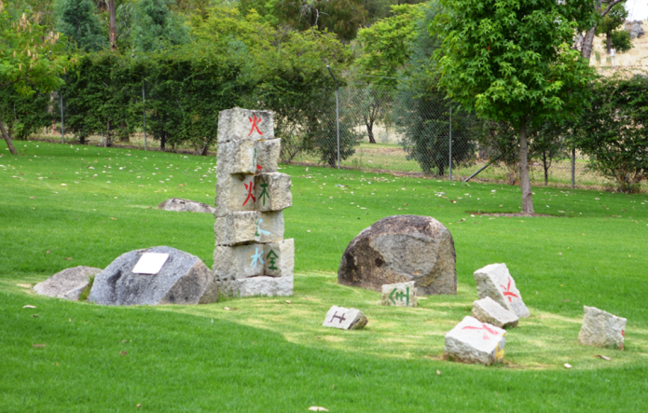

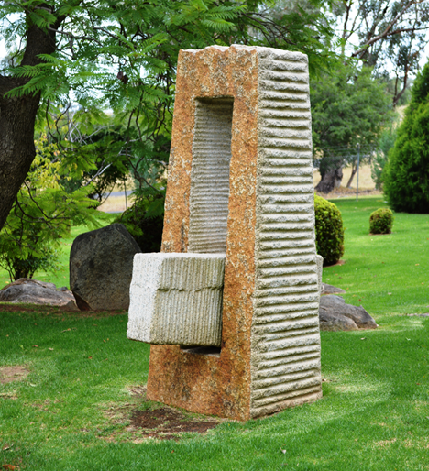

Another sculpture consists of two sculptures which have a single title of The Well of Wisdom jointly sculpted by Katsuhiro Goto and Ken Hutchinson (pictured below).
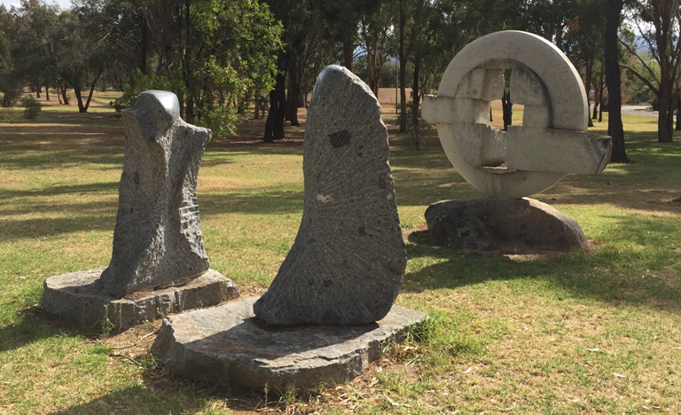

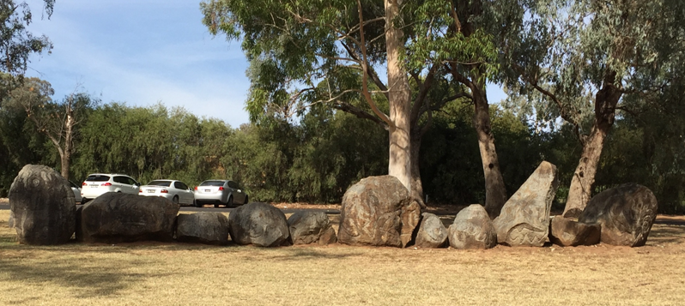
The fifth Sculpture is the oldest in the area being “A Fossil of the Moment”. It will remain in place.

Physical works

The required works for the implementation of the Sculpture Park Landscape plan include:
Stage 1/Year1
Cowra Council staff to prepare, supply and install an irrigation system to water new trees and keep area with good ground cover all year round | $15,000
The supply and planting of new trees as per the plan | $5,000
The removal of artworks from the Japanese Gardens and installation into the Arboretum area | $3,500
Signage for each sculpture | @$800 each being a total of $4,000 for the initial 5 sculptures
Total | $27,500

Stage 2/Year2
Widening, extensions and creation of new and existing pathways at the site Involves approximately 624 square metres of sealed access and pathways | @ $10.00 per square metre totally approximately $6,500.
New stone entrances | $7,500
Ongoing maintenance including extra water requirements in Year 2 and beyond | $8,000 per year
Total | $22,000

The works outlined in the landscape plan total an initial estimated outlay of $27,500 and an ongoing annual maintenance of approximately $8,000 dependent on weather and external factors.
The project is best achieved in two stages:
The first stage/year: installation of the irrigation, planting of trees and establishment of grass cover to areas of viewing traffic: This will allow ground cover to establish and for the trees to take root and also establish into the new areas. This work will prepare the background setting of the landscape plan in readiness for the sculptures.
Irrigation: This will be an underground, fully automated system; a set and forget type to ensure the grass will be green and the trees watered to ensure health and growth, and that the landscape is a suitable back-drop for the setting of sculptures.
The trees can be planted in keeping with the landscape plan: which are in turn in keeping with the area remaining as an arboretum. The placement of specimens will also allow the specific areas to have small and large shrubs as well as small and large trees dependant on the size and form of the area required for the respective sculpture piece.
Year one costs are therefore $27,500 with the maintenance costs of $8,000 per year thereafter.
A major maintenance cost is the provision of water to ensure the area is well presented. This is dependent on weather conditions, however as costs are already allocated for mowing of the areas there would be a small additional cost involved in the maintenance of the area.
The retrieval of the two existing sculptures within the Japanese Gardens and placement into the new area requires the use of machinery to lift from the existing positions and relocation to the new area. The new area would need to be prepared with suitable concrete bases in place, and reinstatement works at the gardens would also need to be carried out . There would also be some minor works required to formalise the existing sculptures within the space. This is estimated to cost $3,500. Year two works total at $22,000.
The Second stage/year: will be the construction of the pathways and stone entrances and the introduction of the two sculptures from the Japanese Gardens.
Pathways construction will involve earthworks to remove the grass and topsoil, then laying and compacting granite before sealing to match the existing paths. This process is estimated at $10.00 per square metre and investigation indicates there to be approximately 650 square metres leaving the costs at $6,500.00. The works consist of widening approximately 200 lineal metres by 0.8 of a metre in width of the existing path, and then extending this pathway for 120 metres at a width of 2.5 metres, through to the intersection of Yarrabilly Drive and Sakura Ave. This will create a 2.5 metre wide shared pathway through the spine of the area, running diagonally from the intersection of Binni Creek Road and Len Whitely Drive.
The remaining paths, linking this spine to the Japanese Gardens and interlinking throughout the sculpture viewing areas and will be constructed at 1.2 metres in width, which is the width of a standard footpath. The lengths required to complete these links is 150 metres.
The stone entrances can be constructed in similar styling to the Peace Precinct gateways, at a much smaller scale and are estimated at $2,500 each. Constructing one at each of the three main entrances to the area. Being Binni Creek Road, Yarrabilly Drive and opposite the main entrance to the Japanese Gardens.

Summary

The Cowra Sculpture Park can be initiated through the Master Plan as presented with modest costs. The initial stage will be to undertake works in preparation to display sculptures already in place together with the relocation of two sculptures from within the Japanese Gardens area. The establishment phase will be undertaken with the Cowra Regional Art Gallery and Cowra Services working together with the overall responsibility for the Sculpture Park under the control of the Gallery Director and the Gallery Advisory Committee.

