00 Date 2024

[Organisation]

Dear Sir/Madam

Re: [ORGANISATION] - Acceptance to run the Cowra MRF Recycling Shop

Your proposal for running the second hand shop at the Cowra MRF has been accepted for a 12 month period commencing Monday Date X, 2024.

The attached documents forming this contact include
- Instrument of Agreement
- Proposal letter from [ORGANISATION]
- Risk Assessment - Second Hand Items Shed-MRF 2023
- [ORGANISATION] Certificate of Currency – Public Liability Insurance valid …

All documents listed comprise the contract between both parties.

To commence this contract please review all documents and confirm the agreement by signing the attached Instrument of Agreement.

Yours faithfully

INSTRUMENT OF AGREEMENT

THIS AGREEMENT is made
BETWEEN

Cowra Shire Council, Private Bag 342, Cowra, NSW 2794. (Council)

AND

[organisation]

IT IS AGREED:
- TERM:
The term of this agreement shall commence on [Date] and shall continue until terminated by either party upon 7 days written notice.

- OPERATIONS:
[Organisation] shall operate the second-hand shop at the Cowra MRF. [ORGANISATION] shall be responsible for the day-to-day operations of the shop, including but not limited to:
  - Managing inventory; All inwards material is required to enter the site over the weighbridge and be assessed by Council staff to determine suitability for diversion to the tip shop. This includes material brought to the site by [ORGANISATION] members. This is to ensure material is not diverted through the tip shop to the waste cell without payment of the appropriate fee. [ORGANISATION] will be required to regularly review stock levels to ensure excess material is not stored around the tip shop site;
  - Prices set for goods sold is the responsibility of [ORGANISATION].
  - Collecting payment for items sold in the shop is the responsibility of [ORGANISATION]. Cowra Council notes the attached certification that [ORGANISATION] has been registered by the Australian Charities and Not-for-profits Commission.
  - Cleaning and maintaining the shop premises;
  - Providing customer service to patrons of the shop;
  - Complying with all applicable policies and regulations related to the operation of the MRF facility.
  - No other material at the MRF facility can be moved to or scavenged for the recycling shop without consultation with the MRF Supervisor.

- PUBLICITY AND ADVERTISING:
[ORGANISATION] shall not advertise or publicly comment on the MRF Second Hand Shop, this agreement, Cowra Council or the MRF Facility without prior written consent from Council. Any breach of this clause shall be considered a material breach of the contract, and Council may terminate the contract immediately and seek damages for any losses resulting from such breach.

- FACILITIES
The Council shall provide [ORGANISATION] with a space within the Council's waste facility to operate the second-hand shop. Acceptance of the proposal specifically refers to use of the facility only in the area of the current footprint of the existing second hand shop at Cowra Materials Recycling Facility. [ORGANISATION] notes the attached Risk Assessment that details identified WHS hazards at the facility. [ORGANISATION] are required to manage all risks identified in the Risk Assessment with a suitable WHS plan for the facility.

- EXPENSES
Cowra Council shall not be responsible for any expenses related to [ORGANISATION] operation of the second-hand shop.

- INSURANCE
[ORGANISATION] shall obtain and maintain public liability insurance coverage in an amount not less than $2,000,000 dollars. Cowra Council notes the attached Certificate of Currency for this insurance. [ORGANISATION] must supply the updated Certificate of Currency on the [DATE] at which time the period of insurance for the attached Certificate of Currency expires.

- INDEMNIFICATION
[ORGANISATION] shall indemnify and hold harmless the Council, its officers, employees, and agents, from and against any and all claims, damages, liabilities, costs, expenses and fees, arising out of or in connection with [ORGANISATION] operation of the second-hand shop.

Notwithstanding any other provision in this contract, the Cowra Council shall not be liable for any actions or decisions of [ORGANISATION] related to the use of money received by [ORGANISATION] for sales of stock. Council assumes no responsibility or liability for the manner in which the [ORGANISATION] spends or allocates any earnings.

- TERMINATION
Either party may terminate this agreement at any time upon 7 days' written notice to the other party. Council may terminate this agreement immediately if [ORGANISATION] violates any provision of this agreement or any applicable law or regulation.

- ENTIRE AGREEMENT
This agreement contains the entire agreement of the parties and supersedes all prior or contemporaneous negotiations, understandings, and agreements between the parties, whether oral or written.

- AMENDMENT
This agreement may not be amended except in writing signed by both parties.

Signed on behalf of and authorised by Cowra Shire Council by:
……………………………………..
Signature of Authorised Person

……………………………………..
Name of Authorised Person
Signed for [ORGANISATION] by:

……………………………………
Signature of Authorised Person

……………………………………
Name of Authorised Person

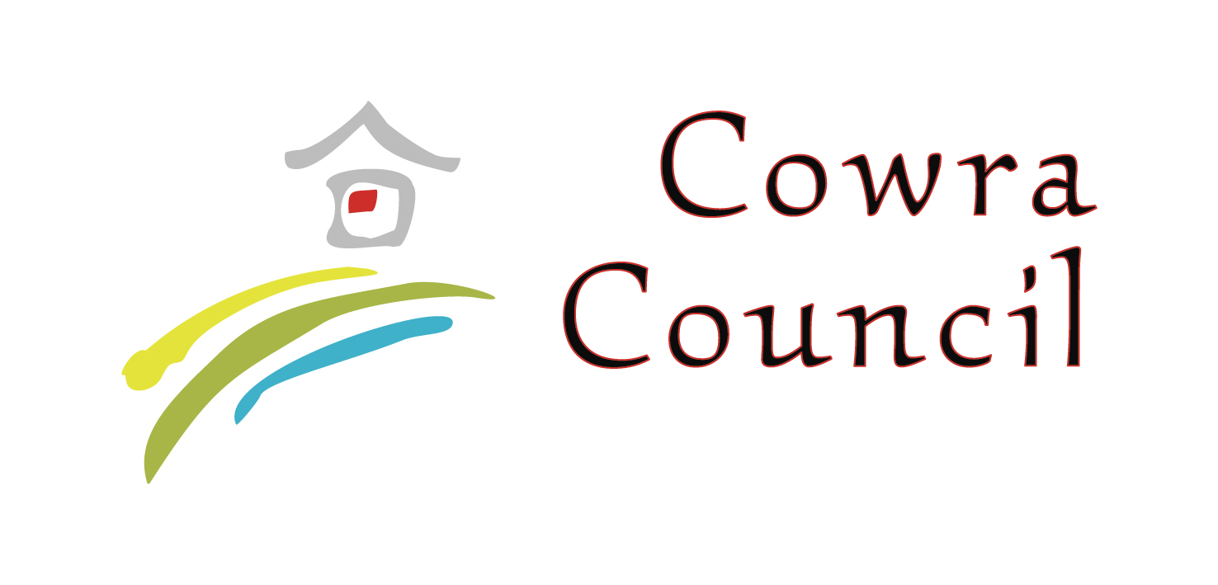

RISK MANAGEMENT OFFICER
CORPORATE SERVICES DEPARTMENT

Report on

Second Hand Items Shed
Materials Recycling Facility

March 9th 2023

Delegation
Delegation for the inspection and subsequent report was issued by the Manager, Cowra Services

Overview
Council has been approached by a third party to manage and operate the Second Hand Items shed at the Materials Recycling facility. The shed is used to store items considered to be suitable for resale. Currently, the items are placed in the shed by MRF staff either on the floor, on tables or on shelves. The shed is maned by a MRF staff member when open and public are asked to pay for items at the weighbridge.

Executive Summary
It is evident from the inspection that there are a number of WHS matters which will require intervention and remedial action.

The limited an electricity supply and the design of the building will have substantial impacts on health and safety in both winter and summer, due to temperature variants. Cowra Community Enterprise will be required to put in place a WHS Risk Management Plan to manage any health and safety risks associated with the structure noting that Cowra Community Enterprise cannot cause any modifications to the existing structure.

Recommendations
The [ORGANISATION] must acknowledge that the building may not comply with the requirements and specifications for a retail outlet as listed in the current Building Codes of Australia Manual as follows.

WHS Matters
The following WHS matters have been identified which have the potential to Increase safety risk to operators and clients
- First aid kit to be placed in shop.
- Fire extinguishers to be placed in the shop.
- Any extension leads and appliances in use need to be test n tagged before being used.
- All volunteers will need to carry out a site induction led the MRF Supervisor and also participate in any evacuation drills when they take place.
- No smoking is permitted in the shop.
- No insulation or lining causing extreme discomfort in both winter and summer
  - This will have a significant effect on people working within the building. In summer the heat will be unbearable, and in winter the frost drip factor from the underside of the roof will increase the risk of slip and fall due to wet and slippery ground.
- Nil airflow
  - Due to the design of the building, there is little or no airflow within the building.
- Limited electricity supply
  - The limited electricity supply will not allow the use of fans or heaters to counteract the extremes of summer and winter as this will likely overload the supply and trip the circuit breaker. No testing of electrical appliances and equipment can be carried out on site. The limited electricity will also effect the ability of the operators to maintain effective cleaning
- Nil water supply
  - This effects the ability of the operators to maintain effective hand hygiene, or general cleaning
- Increased risk from vermin especially snakes due to the building facing onto an open area
  - There have been a number of instances in summer where snakes have been seen around the building.
- Increased risk of trip and fall due to uneven ground and sale items placed on the ground.
- No defined parking area for vehicles or controls for pedestrians. The concern here is that the shed is located at the side of the main parking area for the MRF.
- Lack of suitable amenities in the immediate area
  - Whilst there are toilet facilities available at the main office, there is no provision at the shed for tea making or a sit down area

Additional Considerations
- Security of the building
  - needs to be discussed to ensure that any doors or partitions do not further impede natural airflow, or compromise work space
- Line marking
  - needs to be carried out to identify designated parking including disabled parking, unloading zone, and no stopping zone out the front of the shop.

References
WHS Act 2011
WHS Regulation 2017
Safework NSW, Codes of Practice:
- How to Manage WHS Risks – August 2019
- Managing the Work Environment and Facilities – August 2019

