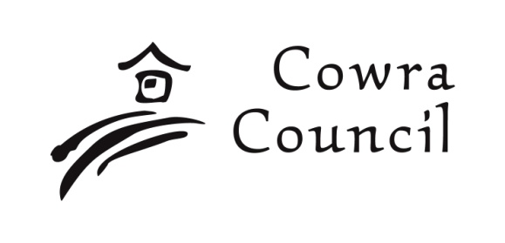 | Cowra Shire Council  Private Bag 342  Cowra NSW 2794  Phone: 02 6340 2000  Fax: 02 6340 2011  council@cowra.nsw.gov.au  www.cowracouncil.com.au

Community Grants Program: Completion and Acquittal Report

Instructions – 2023/24 Round 2

IMPORTANT: The Completion and Acquittal Report and supporting evidence of completion must be submitted to Cowra Council within 30 days of completion of the project.
Suitable evidence of completion includes:
- Photos of your event, project, activity, equipment purchased or facility development undertaken. (Please advise if you do not wish your photos to be used for publicity purposes.)
- Copies of invoices and evidence of payment(s) in full for goods or services supplied by suppliers / tradespersons.
- Copies of media coverage regarding the event, project, activity, equipment purchased or facility development and event records.
- Any other evidence considered to demonstrate that the project has been completed and funds expended.
NOTE: Any attachments provided will be kept as a record by Cowra Council and will not be returned to your organisation.
Organisation Name

Name of the event, project, activity, equipment purchased or facility development undertaken & amount of grant funding received. | Amount of grant funding received:
Signature, name and contact phone number of the person completing this form: | Signature:  Print name:  Phone Number:

1. Please list or describe what your organisation has achieved with the funding provided.

2. Did the completed event, project or activity match outcomes listed in your Funding Application?
If not, please provide reasons why.

3. Did you spend all of the grant funds?  Yes   No    Please note that copies of all supplier receipts relating to grant expenditure must be provided. | If no, the surplus amount was $  Reason(s) for the surplus  Surplus funds must be returned to Cowra Shire Council at the completion of your project. Please contact the Grants and Executive Projects Officer to arrange refund.
Questions 4 and 5 relate to events, projects or activities only.

4. Was the event, project or activity supported by this funding a success? How did you measure the success?

5. How did your event project or activity enable or encouraged members of wider community to participate?

Questions 6 and 7 relate to equipment purchases or facility development.

6. Provide details of the equipment purchased or facility development undertaken?

7. How did the equipment purchased or the facility development undertaken benefit you or members of your organisation.

