Cowra Shire Council Request for EOI for Cowra MRF Shop Agreement

Information for interested not – for – profit organisations

- The Expression of Interest (EOI) opens Friday 5 April 2024 and closes Friday 26 April 2024 and is open to local not-for-profit organisations.

- specifically refers to use of the facility only in the area of the current footprint of the existing second hand shop at Cowra Materials Recycling Facility, (the site). Any permanent changes to the existing structure must be approved by Waste Operations Supervisor Mr Anthony Collins.

- Contract period is for a 12 month period from commencement of the agreement signed by both parties.

- The not-for-profit organisation is responsible for security of the site and Council will not be held liable for damages or items lost.

- The not-for-profit organisation must not make, cause or allow any public announcement, press release or public statement of any kind about this Contract without prior consent of Council.

- The not-for-profit organisation must provide a maximum 1 A4 page submission on why the organisation would like to run the Cowra Tip Shop. The submission must include intended guaranteed opening hours.

- The not-for-profit organisation must provide current public liability insurance certificate to Council for minimum value of $20 million.

- The not-for-profit organisation must provide a Workplace Health and Safety Plan with their application.

- Further information can be obtained by contacting Manager – Cowra Services, Philippa Childs 0417 104 586.

- Council requests that all interested persons provide details of their EOI in writing. A separate form is attached, to be completed and returned to Council prior to the close of the EOI period.

- Submission of an EOI is obligation free. Council reserves the right to negotiate with any or none of the parties who submit an EOI.

Enquiries to: Philippa Childs
Ph: 0417 104 586
Email: pchilds@cowra.nsw.gov.au

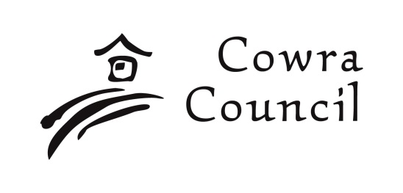 | Cowra Shire Council  Private Bag 342  Cowra NSW 2794  Phone: 02 6340 2000  Fax: 02 6340 2011  council@cowra.nsw.gov.au  www.cowracouncil.com.au
EOI 10/2024 Submission
EOI for Cowra MRF Tip Shop

Not-for-profit organisation name(s)
Please print clearly

Name and Signature(s) of Not-for-profit president

Postal address

Phone Mobile

Email Date

Please include the following documents
- A short (max. 1 A4 page) submission on why your not-for-profit organisation would like to run the Cowra Tip Shop.
- Current public liability insurance certificate to Council for minimum value of $20 million
- A Health and Safety Plan for the tip shop operation.

Please submit this form, marked “Confidential – EOI for Cowra MRF Tip Shop”
- Email: council@cowra.nsw.gov.au
- in person at Council’s Customer Service Centre, 116 Kendal Street, Cowra; or

All EOI must be received by 5.00 pm, Friday 26 April 2024

