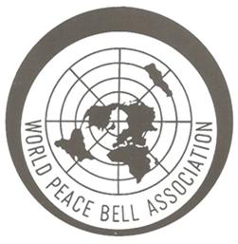 

INTERNATIONAL PEACE DAY POETRY COMPETITION

THEME: “End Racism, Build Peace”

Categories: JUNIOR (5 – 12 years); HIGH SCHOOL (13 – 18 years); and OPEN (18+ years)

As part of 2022’s World Peace Day, the Cowra Branch of the World Peace Bell Association, are staging a poetry competition, with prizes in three categories: Junior, High School and, Open.

The theme of the poem should be in line with this year’s International Peace Day slogan: “End Racism, Build Peace”. The prizes are $100 in each category

A panel of Judges will determine the winner in each category and prizes will be awarded at the Rotary World Peace Day Dinner on Wednesday 21st of September, 2022. Winners will be expected to read their poem at the Dinner.

ENTRANT’S NAME:__________________________________________________________________

SCHOOL (if applicable): _______________________________________ AGE: ____________

ADDRESS:_________________________________________________________________________

TELEPHONE: ______________________ EMAIL: _________________________________________

**Please return this form**

**and a copy of your poem to:** Craig Lawler,

Community Development Officer, Cowra Council.

In person: Council’s Customer Service Centre, 116 Kendal Street, Cowra.

By email: [clawler@cowra.nsw.gov.au](mailto:clawler@cowra.nsw.gov.au)

By mail: Cowra Council, Private Bag 342, COWRA, NSW, 2794.

**All entries must be received by 4.30pm, Friday 16 September 2022.**